 

# Placement Empowerment Program

***Cloud Computing and DevOps Centre***

**Create a Simple Backup Script**

Create a script that backups up your entire Git repository to a local folder daily

Name: Harivignesh S

Department: ADS



# Introduction:

# 

Regularly backing up Git repositories helps safeguard against data loss. This guide explains how to create a simple script using **tar** for Linux/macOS or **robocopy** for Windows to automate daily backups. The process will be scheduled using **cron** on Linux/macOS or **Task Scheduler** on Windows for seamless automation.

# Objectives :

# 

**1. Set up automated daily backups for Git repositories in a local folder.**

**2. Utilize tar for Linux/macOS and robocopy for Windows through shell or batch scripts.**

**3. Keep repository copies updated to enhance data security and prevent loss.**

**4. Schedule backups using cron on Linux/macOS or Task Scheduler on Windows.**

**5. Reduce manual intervention while ensuring efficient and reliable repository protection.**

# Step-by-Step Overview

Step 1

## **Choose Your Backup Location**

Decide where you want to store your backup files.

•Example for **Windows**: C:\GitBackups\

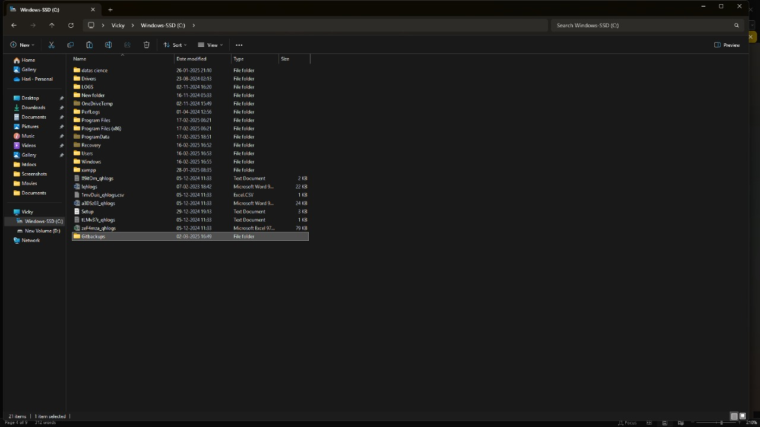

## Step 2

### Create the Backup Script

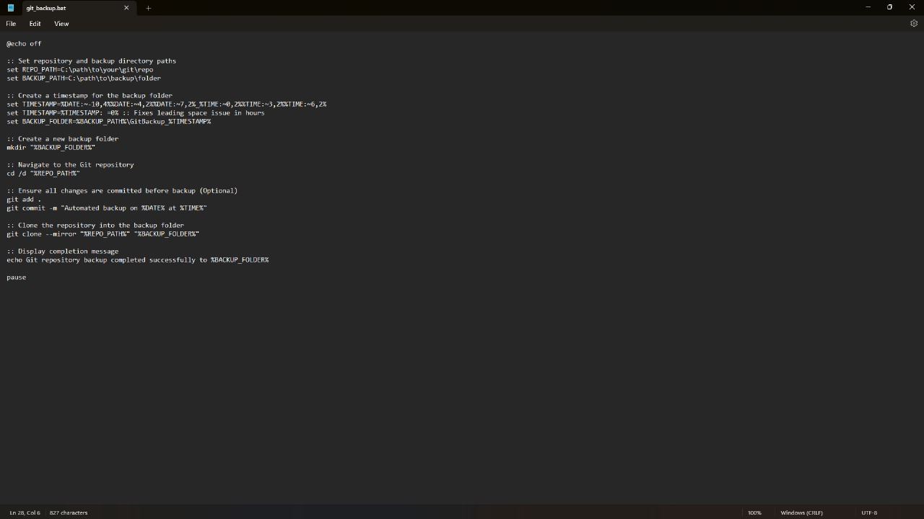

1. Save the file as git_backup.bat.

Step 3

1. **Open Task Scheduler:**
   * Press Win + R, type taskschd.msc, and hit Enter.
2. **Create a New Task:**
   * Click **"Create Basic Task"** in the right panel.
   * Name it **"Daily Git Backup"** and click **Next**.
3. **Set Trigger (Daily Execution):**
   * Select **"Daily"**, set a preferred start time, and click **Next**.
4. **Set Action (Run the Script):**
   * Choose **"Start a Program"**, then browse and select git_backup.bat.
   * Click **Next**, then **Finish** to save the task.

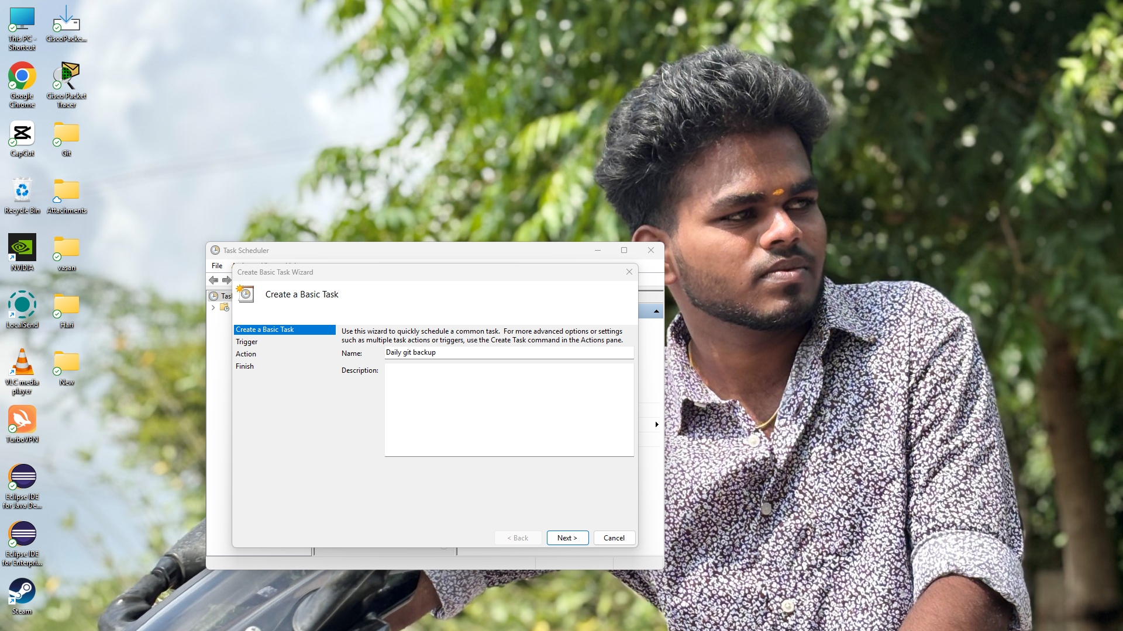

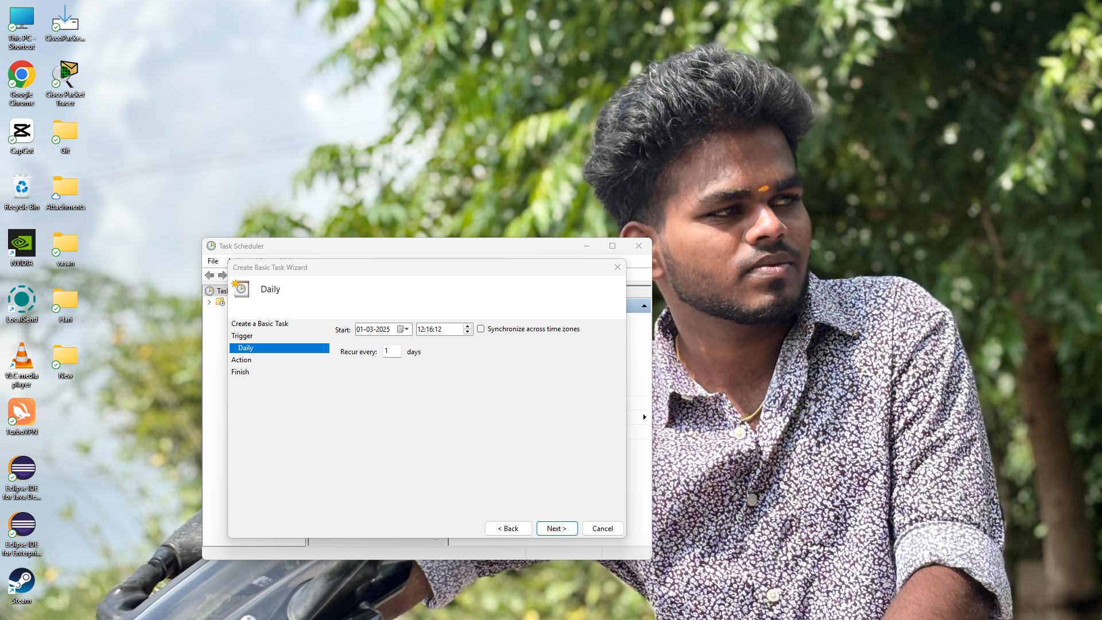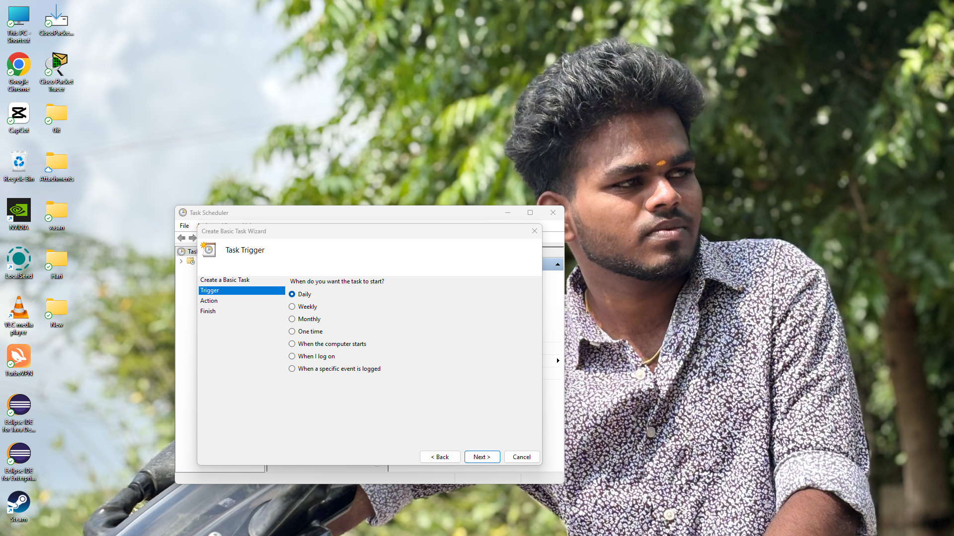

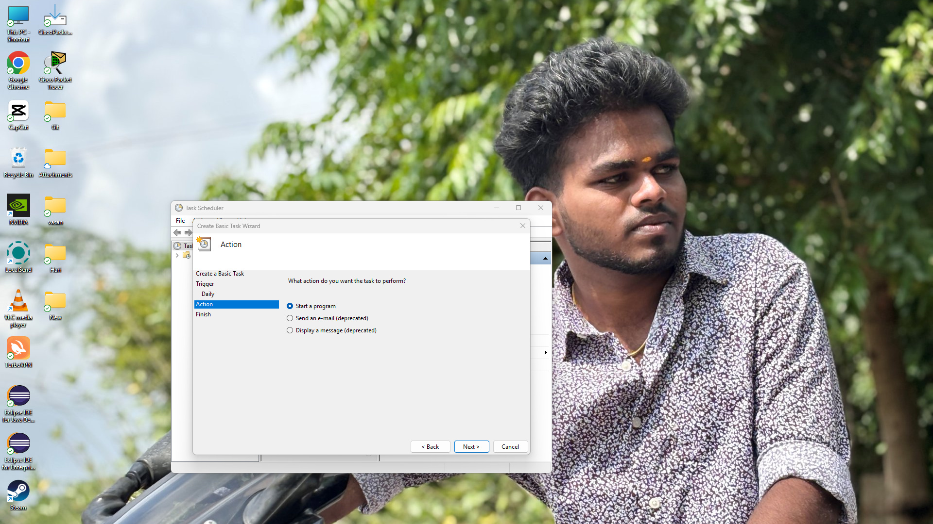

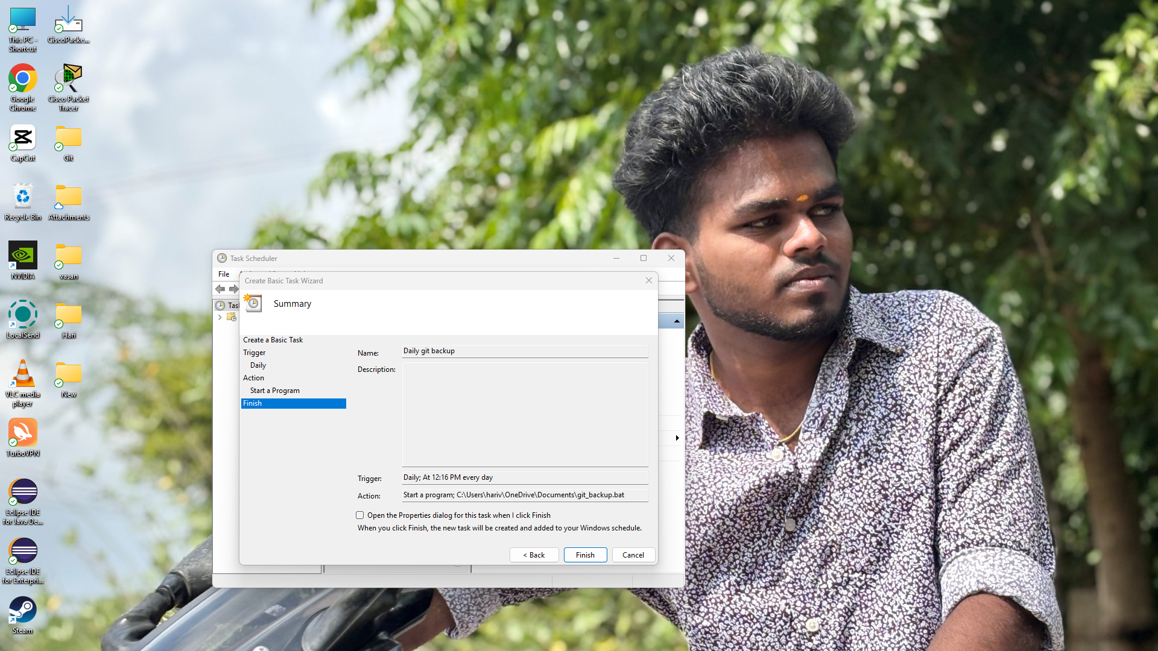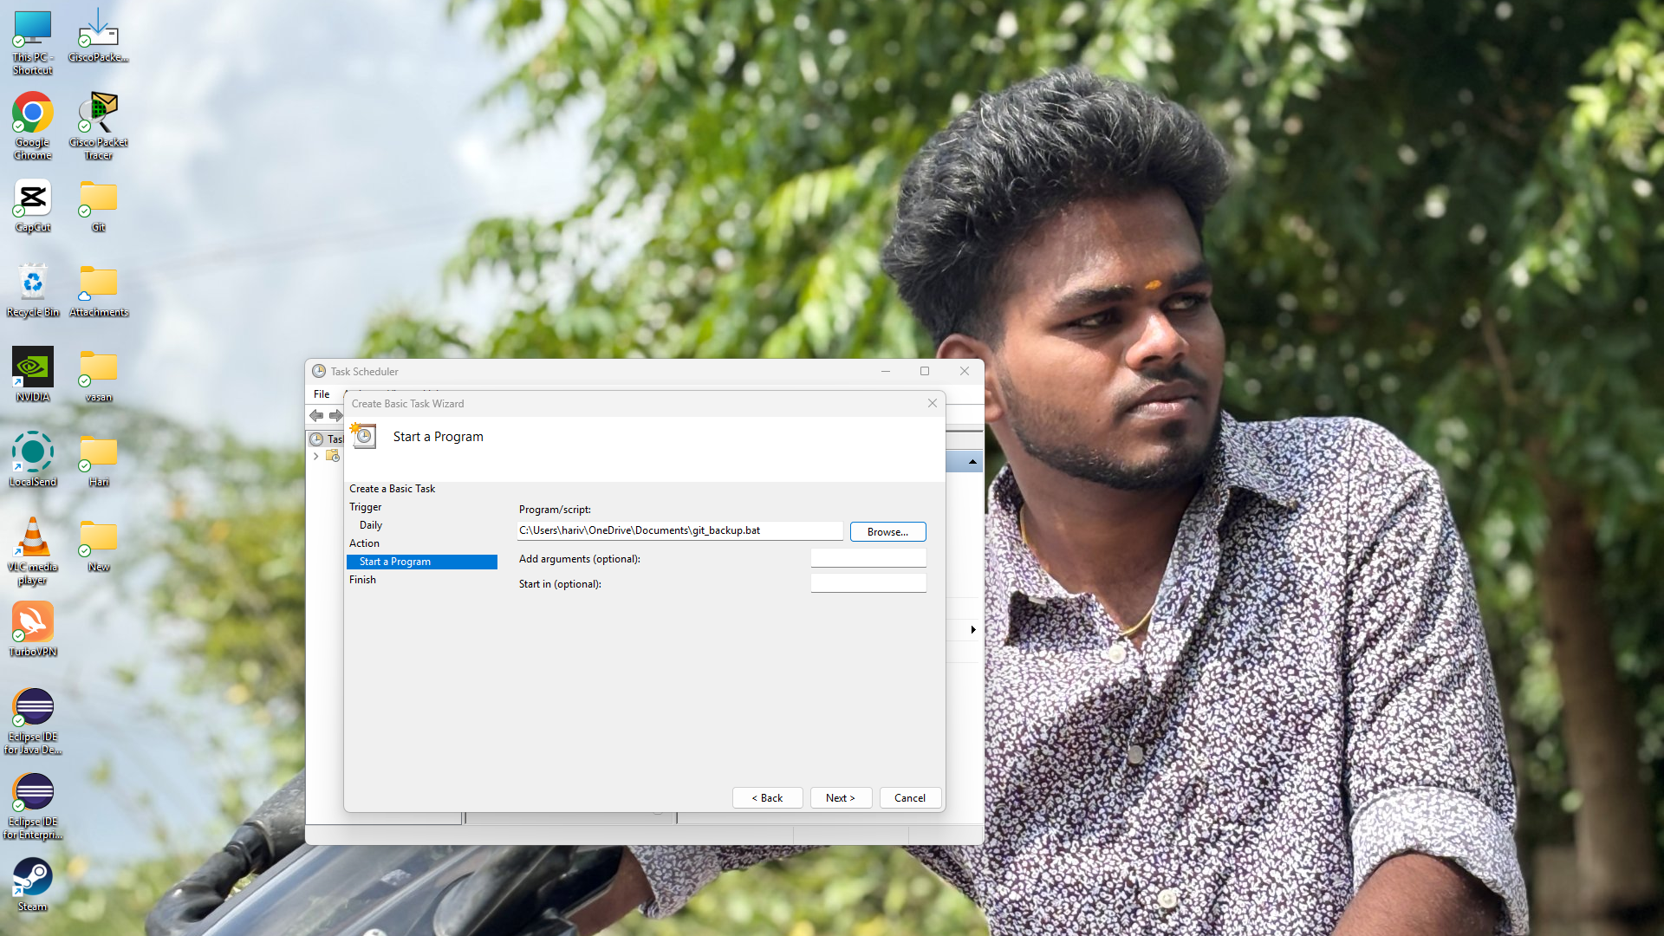

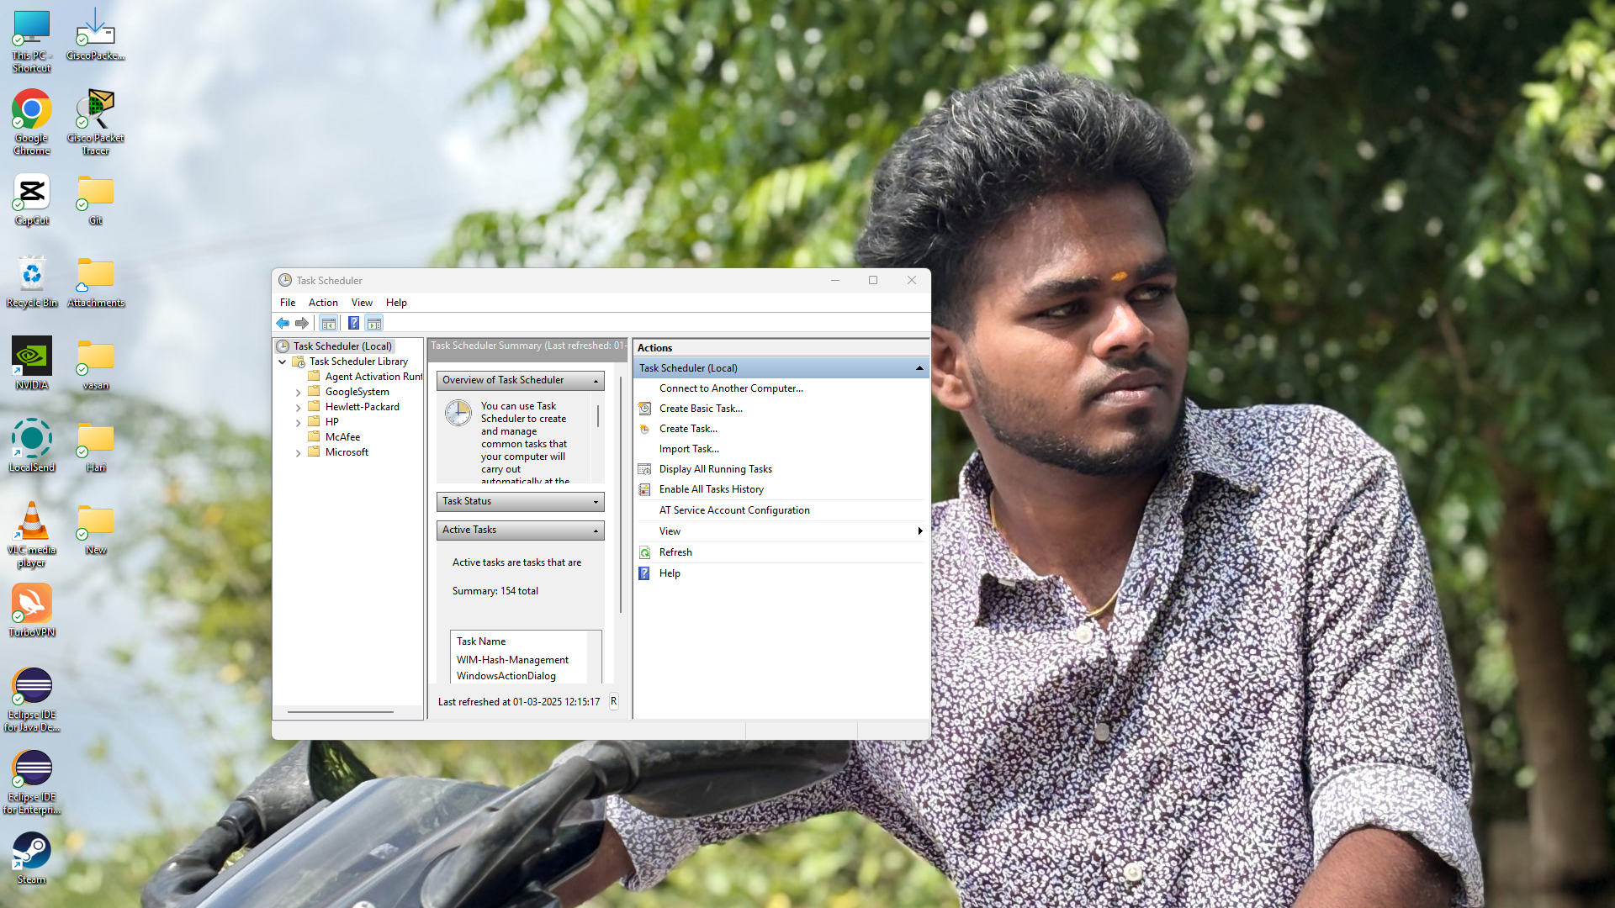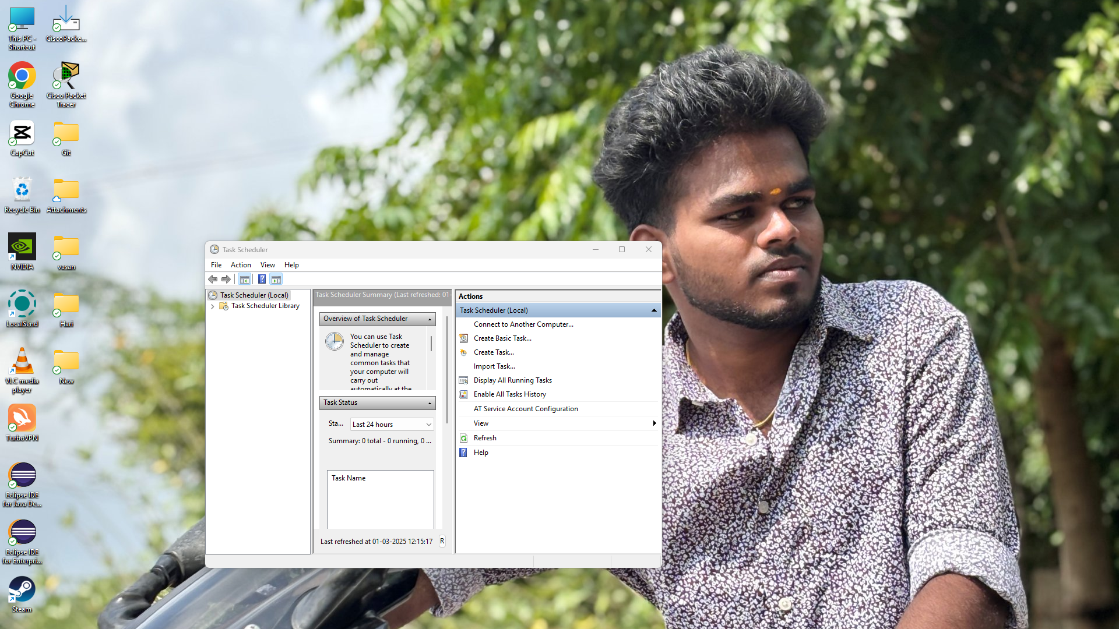

## Step 4

### Verify Your Backups

* Open the backup file to confirm that contains your Git repository in that file.

**Expected outcome:**

1. **Automated Daily Backup:** The script creates a daily backup of the entire Git repository in a local folder.

2.**Scheduled Execution:** The process runs automatically using cron (Linux/macOS) or Task Scheduler (Windows).